**Travel & Hospitality**

**Sky Analytics: Navigating the Complexities of Airline and Airport Operations**



**Background:**

SkyNet Analysis Inc. is a prominent consultancy firm specializing in aviation analytics.

With the aviation industry's rapid expansion and growing complexity, the company plays a vital role in providing data-driven insights to airlines, airports, and regulatory bodies.

Access to extensive datasets enables in-depth exploration of various aspects of the aviation industry, including operational efficiency, delay patterns, and environmental impact.

**Objective:**

The primary goal is to deeply analyze and interpret datasets encompassing flights, airlines, and airports to uncover critical insights.

Key objectives include identifying factors influencing operational efficiency, understanding flight scheduling and delays, and evaluating performance metrics of airlines and airports.

The study ultimately seeks to provide strategic recommendations for enhancing operational effectiveness and improving customer experiences.

**Data Source:**

Flights Dataset: Detailed flight information including timings, delays, and flight-specific data.

Airlines Dataset: Information about various airlines including unique airline codes and full names.

Airports Dataset: Comprehensive details about airports, including unique airport codes, full names, locations, and geographic coordinates.

**Insights:**

The analysis will provide valuable insights into flight operations, delay patterns, airline efficiency, and airport traffic dynamics.

Understanding these insights will enable strategic recommendations aimed at enhancing operational effectiveness and improving customer experiences in air travel.

Key focus areas include identifying trends, understanding operational challenges, and exploring opportunities for improvement across various facets of the aviation industry.

**Part 1: Excel Data Analysis: Manipulation, Formulas and Functions**

**Flight Delays Analysis:**

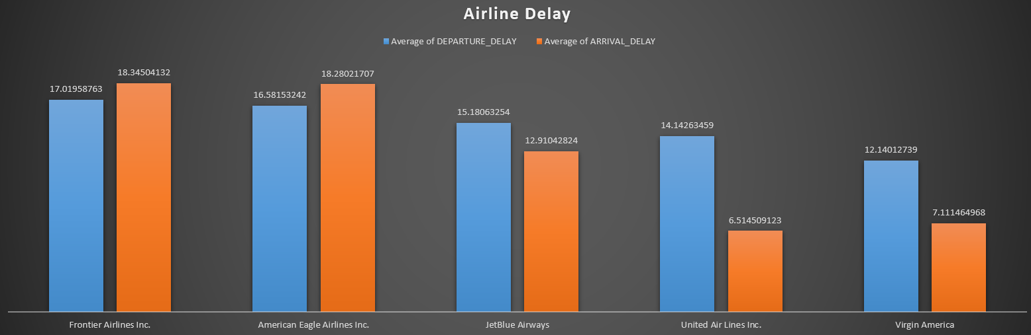

**Insight:**

By determining the average flight delay per airline, the analysis enables benchmarking of airlines' performance in terms of punctuality. Airlines with higher average delays may need to review their operational processes to improve on-time performance and enhance customer satisfaction

**Airport Traffic Volume:**

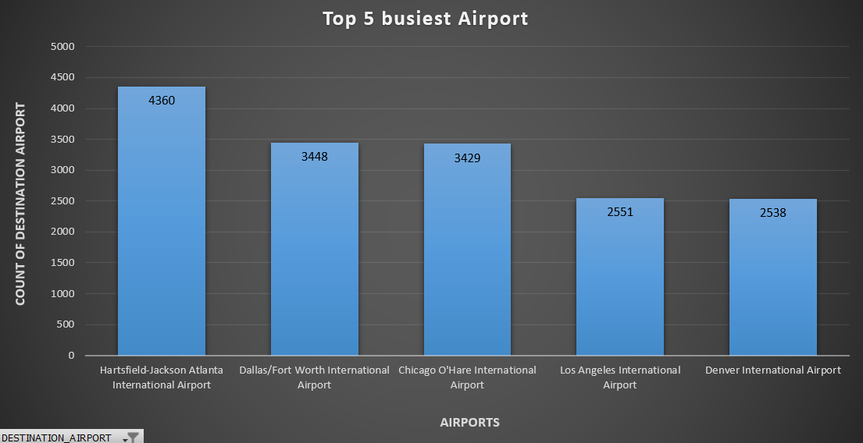

**Insight:**

Identifying the top 5 busiest airports based on incoming and outgoing flights provides insights into the connectivity and accessibility of these airports. Airports with high traffic volumes are likely major transportation hubs, facilitating efficient travel and connectivity to various destinations.

**Flight Cancellation Insights:**

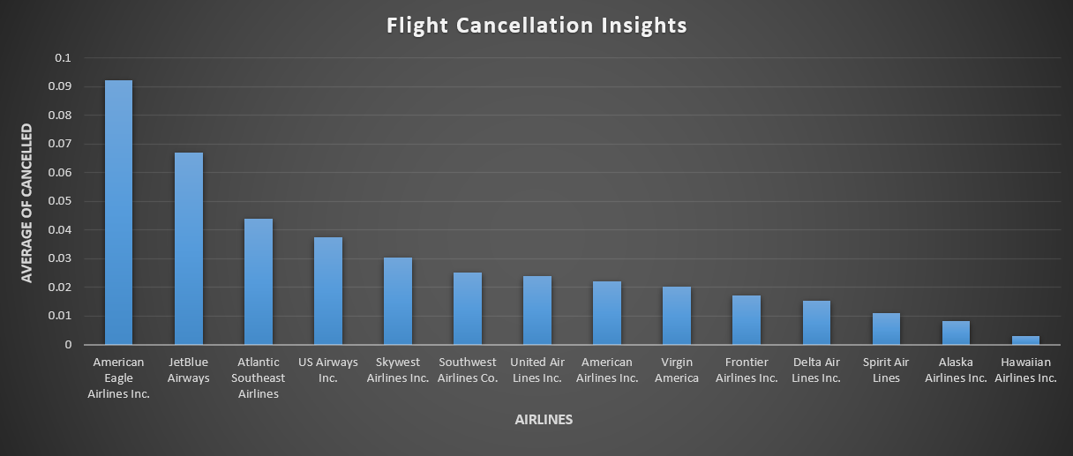

**Insight:**

Analyzing flight cancellations provides insights into airlines' operational reliability and their ability to manage disruptions effectively. Airlines with high cancellation rates may need to review their operational procedures, such as maintenance practices or crew scheduling, to minimize cancellations and improve reliability.

**Seasonal Variations in Flight Operations:**

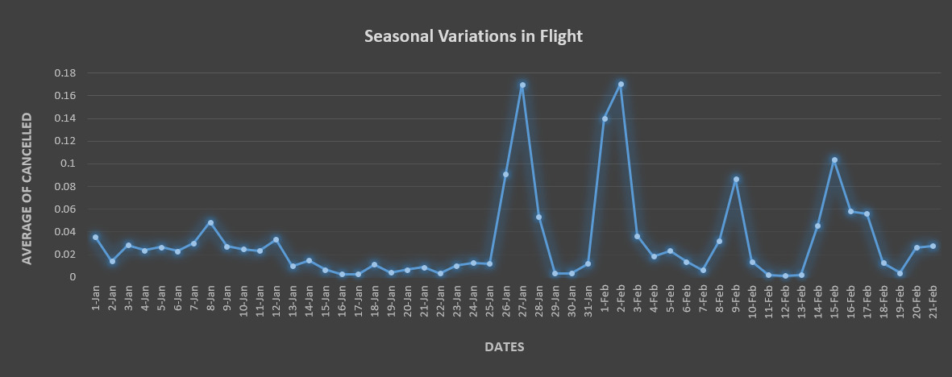

**Insight:**

Seasonal variations in flight operations may coincide with weather patterns, with certain months experiencing higher frequencies of adverse weather conditions such as storms or heavy snowfall. These weather-related disruptions can lead to increased delays or cancellations during specific seasons.

**Correlation between Distance and Delays:**

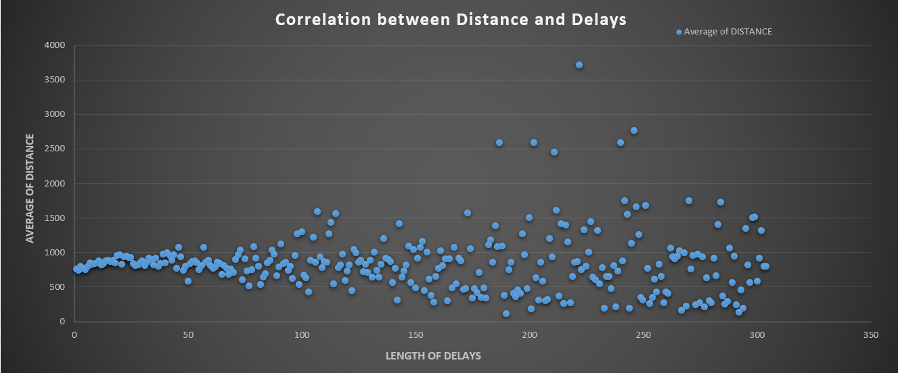

**Insight:**

Investigating the correlation between flight distance and delays provides insights into operational challenges faced by airlines. Longer flights may encounter delays due to factors such as airspace congestion, refueling requirements, or scheduling complexities, impacting overall flight durations.

**Efficiency of Airlines:**

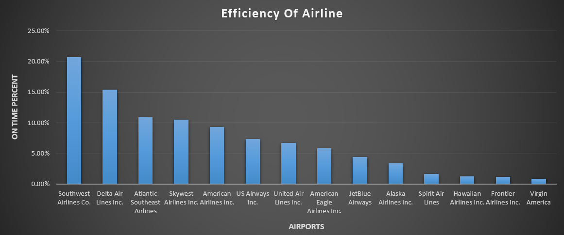

**Insight:**

Calculating the on-time performance for each airline provides a benchmark for assessing operational efficiency. Airlines with higher on-time performance percentages demonstrate greater reliability in adhering to flight schedules, which is crucial for maintaining customer satisfaction.

**Impact of Day of Week on Flight Operations:**

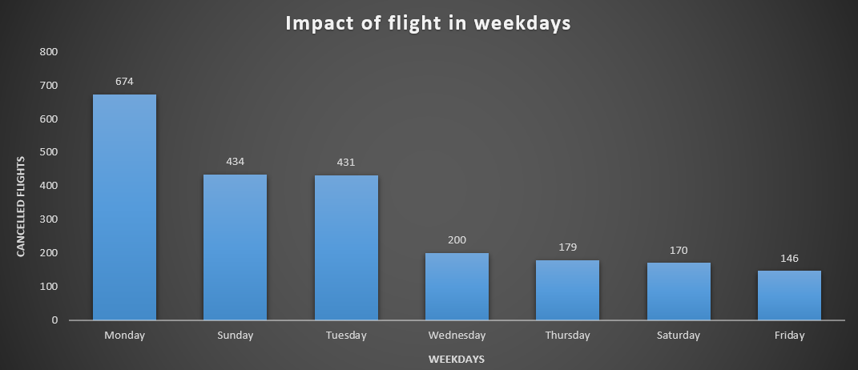

**Insight:**

Flight operations may vary by the day of the week due to fluctuations in passenger demand. Weekends and holidays often witness increased travel activity, leading to higher frequencies of flights and potentially higher incidences of delays or cancellations.

**Analysis of Airport Connectivity:**

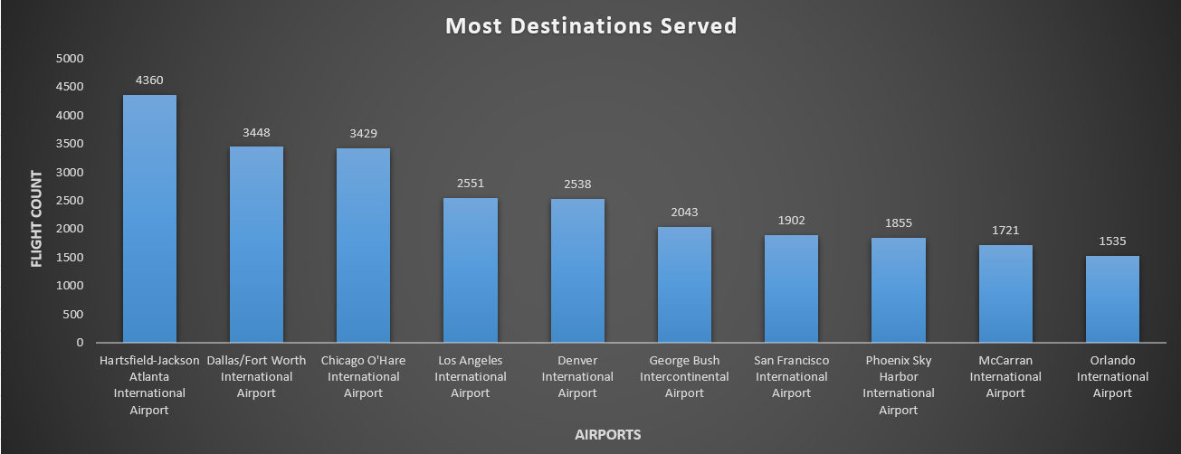

**Insight:**

Comparing scheduled flight durations with actual flight durations allows airlines to identify deviations from planned schedules. Understanding the magnitude of these variances provides insights into factors affecting flight durations, such as air traffic, weather conditions, or operational inefficiencies.

**Flight Duration Accuracy:**

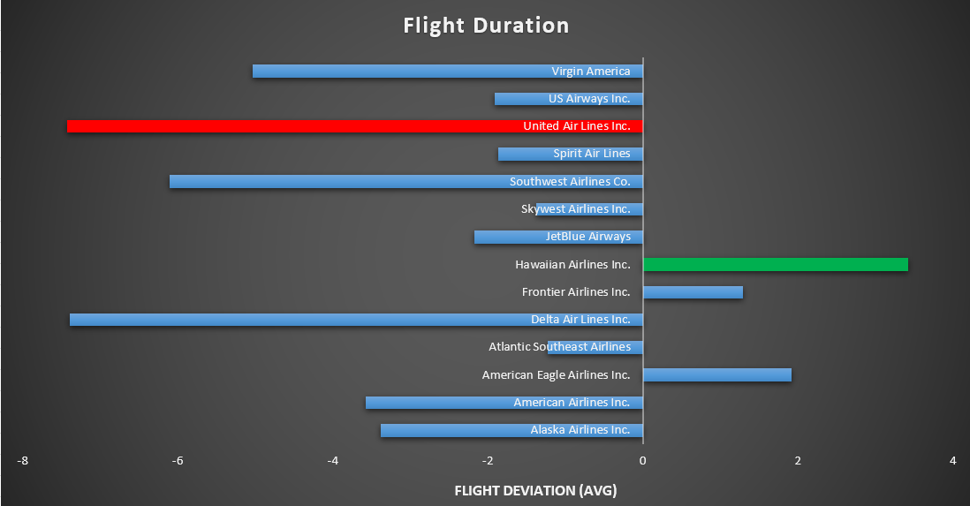

**Insight:**

Comparing scheduled flight durations with actual flight durations allows airlines to identify deviations from planned schedules. Understanding the magnitude of these variances provides insights into factors affecting flight durations, such as air traffic, weather conditions, or operational inefficiencies.

**Airline Fleet Utilization:**

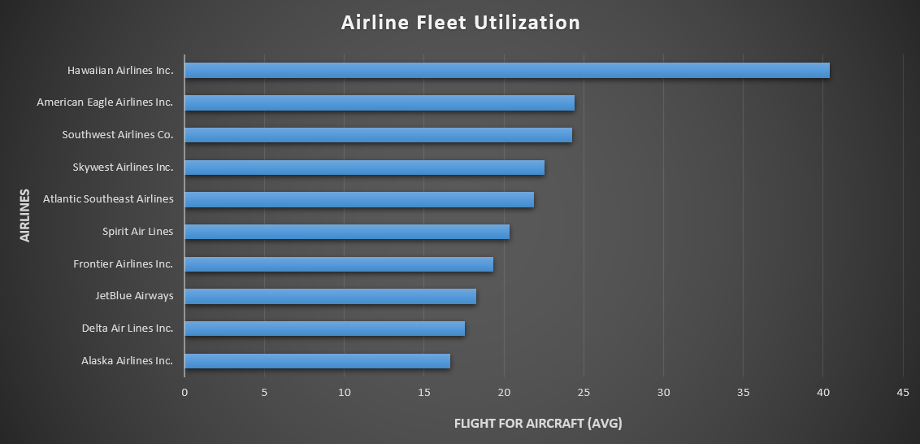

**Insight:**

Analyzing the number of flights per aircraft tail number provides insights into airline fleet utilization. Airlines with high flight-to-aircraft ratios effectively maximize their fleet's operational capacity, optimizing resources and potentially reducing costs.

**Airport Geographical Analysis:**

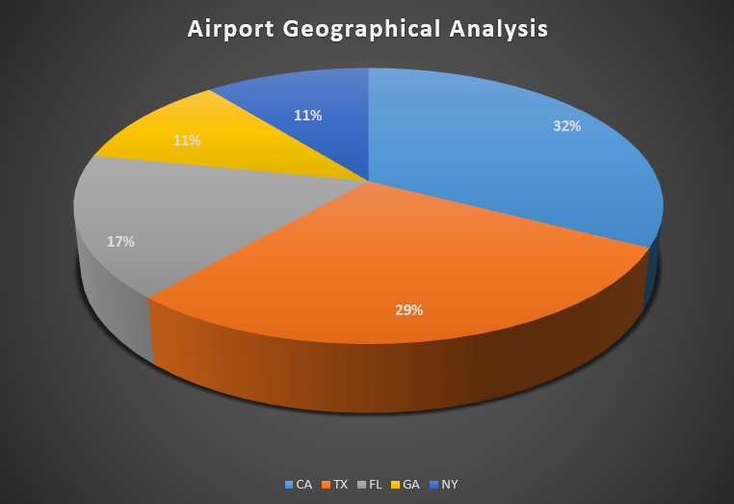

**Insight:**

Analyzing the geographical distribution of airports provides insights into regional air travel patterns and infrastructure development. States or regions with high concentrations of airports often serve as critical air travel hubs, facilitating connectivity and economic development.

**Delayed Flights and Delay Types Analysis:**

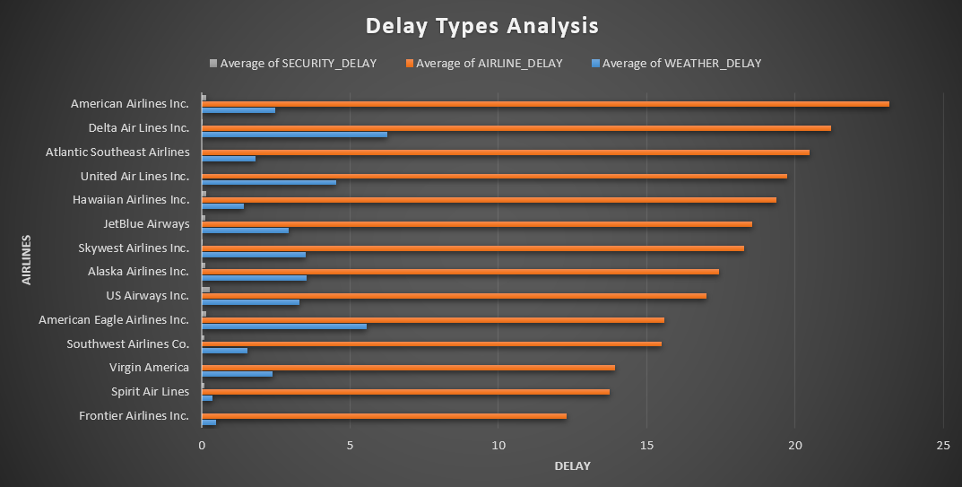

**Insight:**

Analyzing delay types (e.g., airline, weather, security) provides insights into the underlying factors contributing to flight disruptions. Identifying the most common delay types allows airlines to prioritize mitigation efforts and implement targeted strategies to address root causes.

**Long-Haul vs Short-Haul Operations:**

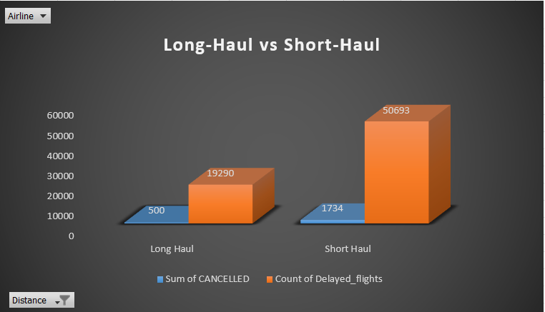

**Insight:**

Comparing operational metrics between long-haul and short-haul flights provides insights into the unique challenges and requirements associated with each category. Differences in delays, cancellations, and other performance indicators reflect distinct operational dynamics and resource allocation strategies.

**Pivot Analysis of Flights Data:**

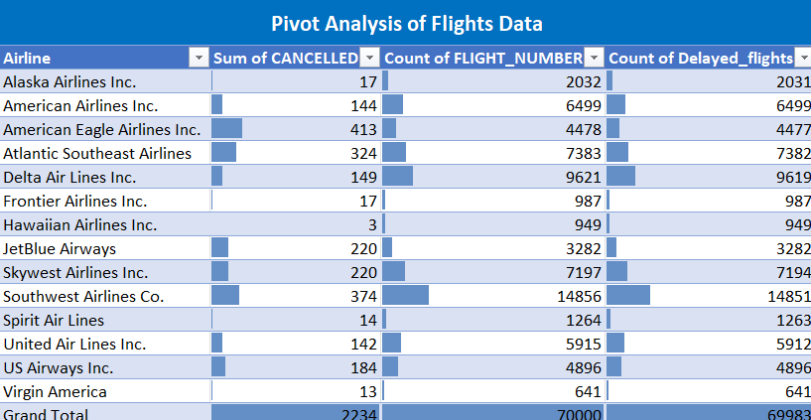

**Insight:**

**Identifying Performance Disparities**:

Pivot analysis reveals significant variations in delay patterns among airlines and airports. Addressing these discrepancies can help streamline operations and minimize disruptions, ultimately enhancing customer satisfaction and loyalty.

**Operational Efficiency Evaluation**:

By aggregating key metrics like on-time performance and cancellation rates, stakeholders gain actionable insights into operational efficiency. Leveraging these insights enables airlines and airports to optimize resources and improve service quality, leading to enhanced competitiveness in the aviation industry.